KIAMA.

There are many caves along the NSW coast, some of which are the result of erosion from the waves, usually associated with a weakness in the rock of one kind or another. Others may show at least some karstic solution. The best known is the Blowhole at Kiama: a cave worn by the sea which enables the water to pass through a small tunnel and emerge as spray through a hole which is a small distance inland.

1. CROWN STUDIOS SERIES

Ph Alex Boles, Kiama
Pu Crown Studios, Sydney (Cook 1986, pp. 133-4)
F Photograph with medium white margin all round; title is superimposed;
photographer's name and a number in lower margin.

1.1 Famous Blow Hole / Kiama / 03011/1 V

2. COCKS PHOTO SERIES [n.l. 1904]

Ph S. Cocks. Kiama & Nowra

F Half-tone print with narrow margin on three sides; title & photographer's name in lower margin with the words “Greetings from” also below title.
2A 2A.1 The Sea Entrance, Blowhole Cave, in calm weather V [pm.4 Sep.1908?]
also has words 'Entrance of Blowhole' superimposed on view.
2A.3 The Blowhole in Storm V [pm.21 Dec.1905] Also has words "Blowhole"
During Storm. Kiama' superimposed on view. Printed title is centred
2A.4 The Blowhole Chasm, Kiama V

F Half-tone print with narrow margin on three sides; title & photographer's name in lower margin but without the words 'Greetings from' in lower margin
2B 2B.1 The Sea Entrance, Blowhole Cave, in calm weather, Kiama V
2B.2 Storm Bay and Blowhole Point, Kiama H [pm.29 Jul.1905]
2B.3a The Blowhole in Storm V [pm.21 Dec.1905] Also has words ‘”Blowhole" During Storm. Kiama’ superimposed on view. Printed title is centred
2B.3b as above, but printed title is justified left [pm. 1906]
2B.4 The Blowhole Chasm, Kiama V [pm.19 Apr.1907]

F Half-tone print with narrow margin on three sides; title & photographer's name in lower margin, printed on the Graphic series back - obviously printed for Cocks by Collins Bros.
2C 2C.1 The Sea Entrance, Blowhole Cave, in calm weather V [pm.14 Apr.1904]
2C.3 The Blowhole in Storm, Kiama V [pm.14 Apr.1904] Note difference in
title.

Message written across both 2C.1 & 2C.3 says, "This Blowhole is one of the
wonderful sights of Kiama - certainly is marvellous - The sea enters a cave
(I'm sending card of this) and blows up a hole about 50 yards from the
entrance with terrific force - The sight is most beautiful. The water is like a
huge waterspout and the spray is felt for a great distance. While here, we have had a storm and the blowhole has been working grandly."

F Photogravure print in decorative frame with title in lower margin, with imprint
on back ;
2D.1 Entrance to Blowhole, Kiama H
2D.2 Blowhole, Kiama, during storm V

F without imprint on back and larger lettering in title.
2E.2 Blowhole, Kiama, during storm V

F Full-frame real photo with superimposed title; some with imprint, others
identified by similar print style.
2F.1 "Blowhole" during storm. Kiama V [pm.5 May 1907] Empire
"Blowhole" during storm. Kiama V [pm.5 May 1907] RP1 "Blowhole" during storm. Kiama V [pm.5 May 1907] K-A
"Blowhole" during storm. Kiama V [pm.5 May 1907] K-D
2F.2 Blowhole during storm / Kiama SC1036 V K-D
Blowhole during storm / Kiama SC1036 V K-D(5)
2F.3 Blowhole. Kiama. S.C. V [ms.1 May 1908] (s.n.a. 2F.2) K-A
Blowhole during storm / Kiama SC1036 V RP1
2F.4a "Entrance of Blowhole" S.C. V [ms.1 May 1908] RP1
"Entrance of Blowhole" S.C. V K-D(4)
2F.4b Entrance of Blowhole V K-D
Entrance of Blowhole V K-F
2F.4c Entrance of Blowhole V K-D
Entrance of Blowhole V, but without title Empire
Message on back reads "This picture is the entrance to the 'blowhole'. The sun was shining down the 'blowhole' proper when the picture was taken which
makes the whitish look at the back of the cave." [ms. 10 Nov.1908]
(The 2F.4cards are all from different negatives)
2F.5 The Chasm/of Blowhole/Looking down chasm/during calm weather
SC10?7 V K-D
SAME K-D(8)
2F.6 The Blowhole/Kiama/63 Copyright V K-D(Y)
2F.7 The Blowhole/Kiama 110 S.C. H Empire
2F.8 "The Chasm" of Blowhole/after spray V K-D
2F.9 The Blowhole / Kiama V British

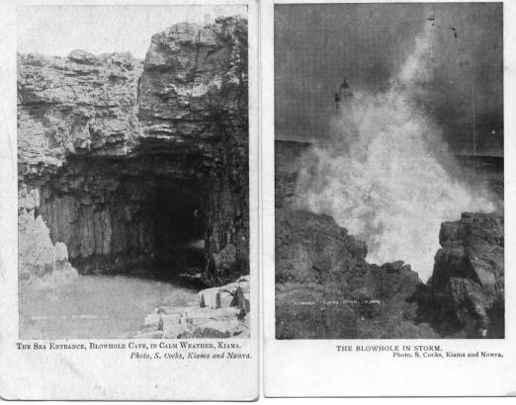

3. SWAIN & CO. SERIES

Pu Swain & Co., Sydney (Cook 1986, p. 151)

3A. F White margin all round, wider at R.H. end; title superimposed on view;
undivided back

3A.1 The Blow Hole - Kiama H [pm.20 Apr.1905]

3B. Pr in Germany
F Full frame halftone picture (s.n.a. 3A.1) with superimposed title.

3B.1a The Blow Hole, Kiama H (s.n.a.5A.1) Control 155/113175 on back 3B.1b The Blow Hole, Kiama H Control 77667 on back

3C. Pr in Saxony
F Full frame print in sepia with gloss surface (real photo?) ; superimposed title and serial (?) number.

3C.1 The Blow Hole/Kiama, N.S.W. / Rn2449 H

3D. F Full-frame view in colour with title superimposed but contained in black
tablet.

3D.1 The Blow Hole, Kiama, N.S.W. H (s.n.a. 5A.1)
3D.2 The Blow Hole, Kiama, N.S.W. H [pm.6 May.1907]

3E. F Full-frame view as 3B but in colour with title superimposed at top. Control
mark 155/113175.

3E.1 The Blow Hole, Kiama H

4. ROSE SERIES

Pu Rose Stereograph Co., Armidale
F Standard Rose format

4.P951 The Blowhole, Kiama, N.S.W. V R4
4.P5723 Entrance to the Blowhole, Kiama, N.S.W. H R2a, R3, R4
4.P5740 The Blowhole, Kiama, South Coast, N.S.W. H R4
4.P7541 The Entrance to the Blowhole, Kiama, N.S.W. H R5
4.P5753 The Blowhole, Kiama, South Coast, N.S.W. *
4.P5766 The Blowhole, Kiama, South Coast, N.S.W. *
4.P5779 The Blowhole, Kiama, South Coast, N.S.W. R3
4.P8656 The Blowhole during a storm, Kiama, N.S.W. V R5

F Coloured real photo with white margins; title in lower margin; back is R9; use of same negative, general appearance, and typeface suggest a Rose card,
but there is no imprint.

4B.1 The Blowhole during a storm, Kiama V (s.n.a. 4.P8656)

5. HARDING & BILLING SERIES

Pu Harding & Billing, Sydney (Cook 1986, pp. 134-8)
F Photo printed in ornamental green frame (A) or with
medium white margins (B)

5A.1 The Blow Hole, Kiama V
5B.1 The Blow Hole, Kiama V
5B.2 The Blow Hole, Kiama H

6. STAR PHOTO CO. SERIES

Pu Star Photo Co. (Cook 1986, pp. 150-1)
F Half-tone print with margins all round; title and
imprint in wide lower margin.

6.1 Blowhole, Kiama, near Sydney V

7A. S.W. "NATURE" SERIES

Pu Samuel Wood, Sydney (Cook 1986, pp. 155-6)
Pr In Saxony
F Full-frame colour print with superimposed serial number and title.

7A.1481 The Blow Hole, Kiama H

7B. SW / Beagles Series
Pu Samuel Wood (Cook 1986, pp. 155-6)
Pr & Pu J. Beagles & Co. Ltd., London (Byatt 1978, p. 40)
F Hand-tinted real photo with white margins, and serial number (incorporated
below).

7B.1282 Blowhole, Kiama H [pm. Feb. 1907]
7B.3044 Greetings from Kiama H [ms. 30 Dec.1907]
(comprises four views with floral motifs on dark background)

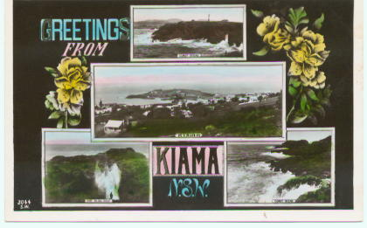

8. TUCK'S OILETTE SERIES 7357 - ILLAWARRA : THE GARDEN OF
AUSTRALIA.

At A.H. Fullwood
Pu Raphael Tuck & Sons Ltd.
Pr In Great Britain (by Tuck's)
F Printed from oil painting with title and artist's name superimposed.
Series includes 0NLY one card relevant to this listing.

8.1 Illawarra NSW / Blow Hole, Kiama V

9. KERRY
Ph Kerry
Pu Kerry & Co.

Kerry Series 100
Pr In Germany by Collotype
F Usual Kerry format
9.1 The Blowhole Kiama V

Greeting Card
Pr & Pu Kerry & Co.
F Hand-tinted real photo in decorative frame
  - The Blowhole 2500 V Border has message ‘Hearty Greetings/ and Best
Wishes/ from Kiama’ [pm. 13 Oct. 1909] K-A

Full-frame Real Photo
Pr & Pu Kerry & Co.
F Full-frame real photo with individual number
9.34 The Blow Hole / Kiama V K-A
  - The Blow Hole / Kiama V with ‘Greetings / from Kiama / N.S.W.’
In decorative script across top of card K-A

10. GIOVANARDI COPPERSTYLE SERIES [n.l. 1906]

Pu G. Giovanardi, Sydney (Cook 1986, p. 134)
F Brown-tinted half-tone print with title in broad
R.H. margin.

10.211 The Blow Hole/ Kiama. N.S.W. H [pm.8 Jan.1906]

11. VALENTINE SERIES

Pu Valentine's
F Narrow frame and superimposed title.

11.1 The Blowhole, Kiama, N.S.W. H (also serial #V13) V10

12. M.J. SULLIVAN SERIES

12A
Pr in Australia
Pu M. J. Sullivan, Kiama
F Full-frame photogravure, with title in white.

12A.1 Blow Hole, Kiama V

12B
Pr in Germany by Collotype
Pu M.J. Sullivan, Kiama
F Full-frame Collotype with title in black.

12B.2 Blow Hole - Kiama V

13. PITT SERIES

Pu C.A. Pitt Ltd., Payneham, S. Aust.
F Real photo with white margins ; title and number (used below) in lower
margin

13.2135 The Blowhole, "Blowhole Point" Kiama, N.S.W. H
13.2136 The Blowhole, "Blowhole Point" Kiama, N.S.W. H
13.2139 Entrance Channel of the Blowhole. "Blowhole Point." Kiama. N.S.W. H

14. SELDON SERIES

Pu Seldon, Rotorua, N.Z.
F Greenish-black full frame half-tone with superimposed title ; publisher imprint both superimposed & on back

14.1 A stormy day at Blowhole Point, Kiama, Illawarra V (pm.20 Jan.1908)

15. MOWBRAY SERIES

Pu Mowbray
F Real photo with superimposed title

15.1 The Blowhole/Kiama/South Coast N.S.W. V

16. T. NARBETH SERIES

Pu T. Narbeth, Aberdeen House, 204 Clarence St., Sydney
F Sepia real photo with white margins; title, number and imprint in lower margin.
Use of same negative, general appearance, and even detail of printing suggests this was printed by Rose for Narbeth.

  - Blowhole during storm, Kiama V (s.n.a. 6.P8656)

- MURRAY VIEWS

Pu & Pr Murray Views

17 Full Colour real photo with deckle edge
17C.1 Kiama, N.S.W./ The Little Blowhole and Lookout H

- GARRICK POSTCARDS

Ph Uwe Steinward
Pu & Pr Garrick
F Full colour real photo with deckle edge
18.1 Blowhole, Kiama, N.S.W. H

- COLOUR TECH

Colour print with white margin; title in white and red

Blowhole, Kiama V

Various Unidentified Kiama
Real photo; a montage of six small framed prints with a spray of flowers Kiama V [pm.7 Jan.1909] RP1. | 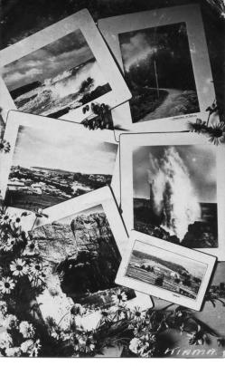

Real photo of Kiama Blowhole, vertical format with medium white margins, no title, divided back with control 11 3 11 in stamp box | 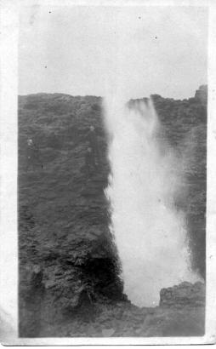

Real photo with superimposed title roughly hand-lettered as The /Blowhole/ Kiama V K-D(1) | 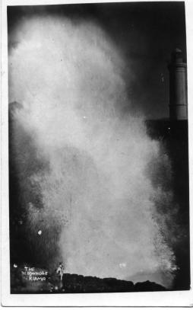

Coloured real photograph; vertical format; white margin with title The Blowhole, Kiama, N.S.W in lower margin | 